**Capstone Project**

**The Battle of the Neighborhoods, Turin**

**Applied Data Science Capstone by IBM/Coursera**

**Introduction: Business Problem**

In this project we will try to find an optimal location for a restaurant. Specifically, this report will be targeted to stakeholders interested in opening a **vegetarian/vegan restaurant** in **Turin**, Italy.

Since there are lots of restaurants in Turin (particularly in the center) we will try to detect **locations that are not already crowded with restaurants**. We are also particularly interested in **areas with no vegetarian or vegan restaurants in vicinity**. We would also prefer locations **as close to city center as possible**, assuming that first two conditions are met.

We will use our data science powers to generate a few most promising neighborhoods based on these criteria. Advantages of each area will then be clearly expressed so that best possible final location can be chosen by stakeholders.

**Data**

Based on definition of our problem, factors that will influence our decision are:

* number of existing restaurants in the neighborhood (any type of restaurant)
* number of and distance to vegetarian or vegan restaurants in the neighborhood, if any
* distance of neighborhood from city center

We decided to use regularly spaced grid of locations, centered around city center, to define our neighborhoods.

Following data sources will be needed to extract/generate the required information:

* centers of candidate areas will be generated algorithmically and approximate addresses of centers of those areas will be obtained using **Open Street Map API reverse geocoding**
* number of restaurants and their type and location in every neighborhood will be obtained using **Foursquare API**
* coordinate of Turin center will be obtained using **Open Street Map API geocoding** of well known Turin location (Piazza Castello)

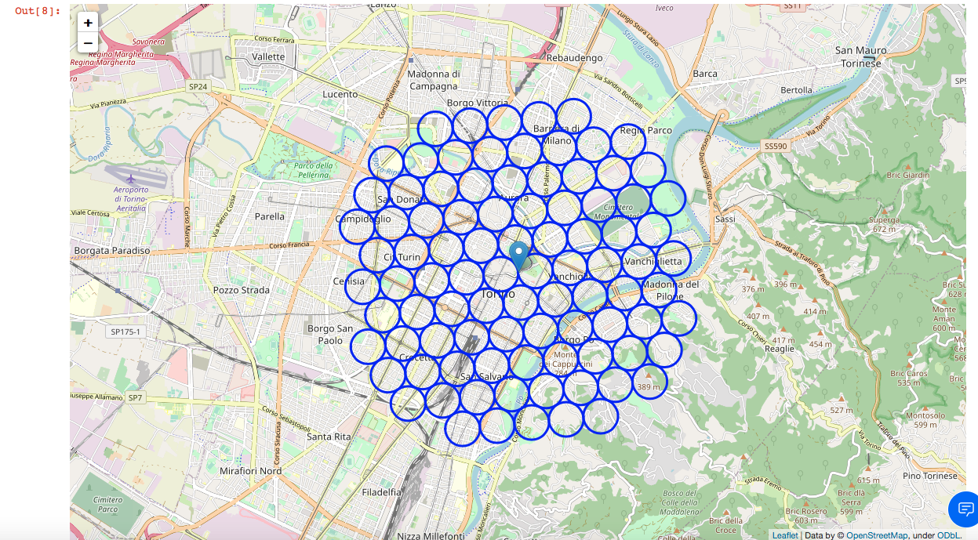FIG. 1) Screenshot of the regularly spaced grid of locations generated.

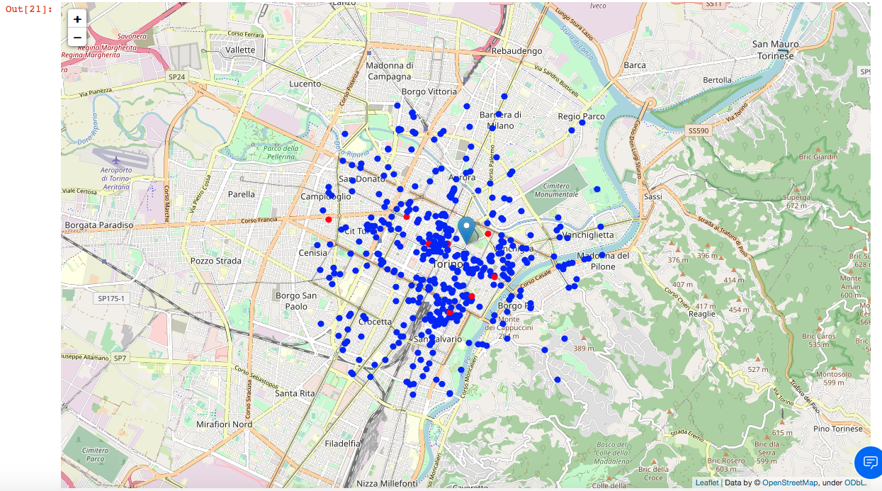

FIG. 2) Screenshot of the restaurants around the city center (the red ones are the veg ones).

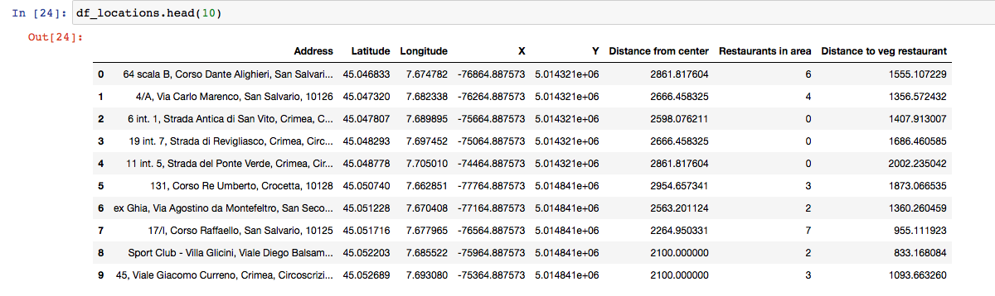

FIG. 3) Screenshot of the dataframe with the info for every grid (see FIG. 1).

## Methodology

In this project we will direct our efforts on detecting areas of Turin that have low restaurant density, particularly those with low number of vegetarian and vegan restaurants. We will limit our analysis to area ~3km around city center.

In first step we have collected the required **data: location and type (category) of every restaurant within 3km from Turin center** (Piazza Castello). We have also **identified vegetarian and vegan restaurants** (according to Foursquare categorization).

Second step in our analysis will be calculation and exploration of '**restaurant density**' across different areas of Turin - we will use **heatmaps** to identify a few promising areas close to center with low number of restaurants in general (and no vegetarian/vegan restaurants in vicinity) and focus our attention on those areas.

In third and final step we will focus on most promising areas and within those create **clusters of locations that meet some basic requirements** established in discussion with stakeholders: we will take into consideration locations with **no more than two restaurants in radius of 100 meters**, and we want locations **without vegetarian and vegan restaurants in radius of 400 meters**. We will present map of all such locations but also create clusters (using **k-means clustering**) of those locations to identify general zones / neighborhoods / addresses which should be a starting point for final 'street level' exploration and search for optimal venue location by stakeholders.



FIG. 4) Average distance to closest veg restaurant from each area grid center.

OK, so **on average a vegan/vegetarian restaurant can be found within ~1.2km** from every area center candidate. That's not close and very good for the stakeholders, but we need to filter our areas carefully!

Let's create a map showing **heatmap / density of restaurants** and try to extract some meaningful info from that. Also, let's show a few circles indicating distance of 1km, 2km and 3km from Piazza Castello.

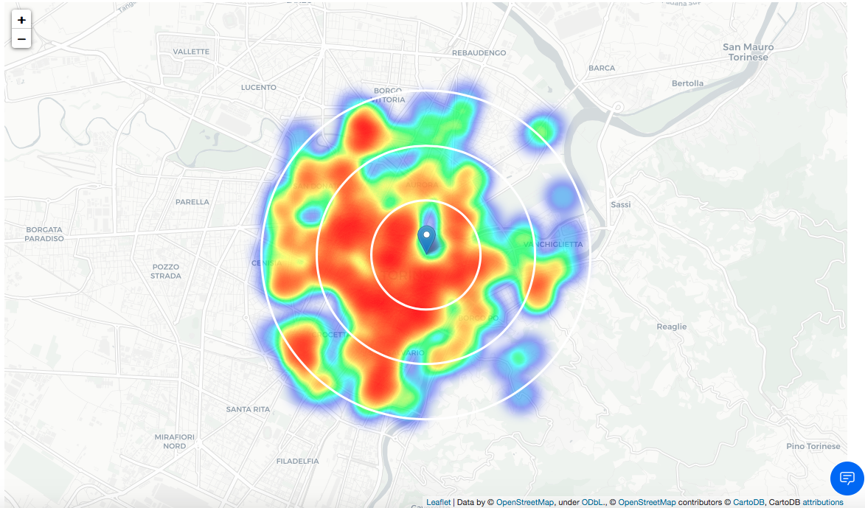

FIG. 5) Density of restaurant around the city center (Piazza Castello).

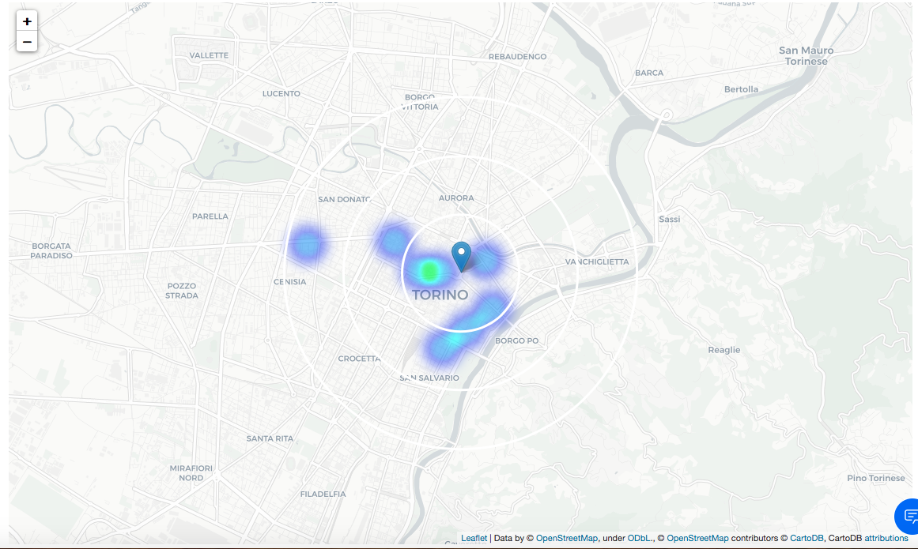

FIG. 6) Density of veg restaurant around the city center (Piazza Castello).

The second map is not so 'hot' (vegetarian and vegan restaurants represent a subset of only ~2% of all restaurants in Turin) but it also indicates higher density of existing vegan/vegetarian restaurants directly near from Piazza Castello, with closest pockets of **low veg restaurant density positioned north, east and south-west from city center**.

Based on this we will now focus our analysis on areas *north, north-east from Turin center* - we will move the center of our area of interest and reduce it's size to have a radius of **1.5km**. This places our location candidates mostly in boroughs **Borgo Vanchiglia** and **Borgo Dora** (in the map respectively Vanchiglietta and Aurora). Another potentially interesting borough is **Crocetta** with a low restaurant density south/south-west from city center. However this borough is mostly residential, not so popular with tourists and maybe is less interesting to stakeholders.

### Borgo Vanchiglia and Borgo Dora

These are some analysis and reviews I found on the web about these boroughs:

**Borgo Vanchiglia**

*"The favorable central position and the proximity to the University of Turin have led, both in Vanchiglia and in Vanchiglietta, to a gradual transformation into residential neighborhoods. In more recent years, Borgo Vanchiglia has established itself as one of the driving forces of Turin's artistic and commercial creativity. The artisan shops, still present, were joined by various artistic and cultural realities of different fields, such as architecture, design, sculpture, painting, theater, music, cinema. For a few years, the Borgo has become a theater of contrasting realities between the economic crisis that has hit small shops and the new places dedicated to youth nightlife, a question that remains an open topic of discussion today on the nightlife."* (wikipedia.org)

**Porta Palazzo (located in Borgo Dora)**

*"Open every weekday, it represents the multiethnic heart of Turin. The market area of Porta Palazzo is located close to the Roman Porte Palatine, and has undergone a profound redevelopment in recent years, which however still requires a strong implementation. The ancient art nouveau clock canopy stands out, built in cast iron, iron and glass. It is currently the largest open-air market in Europe with almost 1,000 mobile stalls for the sale of fruit and vegetables, food and clothing."* (wikipedia.org)

**Balon (located in Borgo Dora)**

*"Balon (pronounced buh-loon) is the biggest flea market in Europe. It takes place each Saturday morning and every second Sunday in Borgo Dora (Aurora), one of the most characteristic boroughs of the area. Here, many antiquity shops put their merchandise on display, making strolling through the market a truly wonderful and often bizarre experience. Expect everything from antique night stands to piles of old TV remotes, from old comic books to used eyeglasses!"* (theculturetrip.com)

These boroughs are popular with tourists (one more famous for the artistic life and the nightlife and the other for being the most characteristic boroughs of Turin) relatively close to city center and well connected, those boroughs appear to justify further analysis.

Let's define new, narrower region of interest, which will include low-restaurant-count parts of Borgo Vanchiglia and Borgo Dora closest to Piazza Castello.

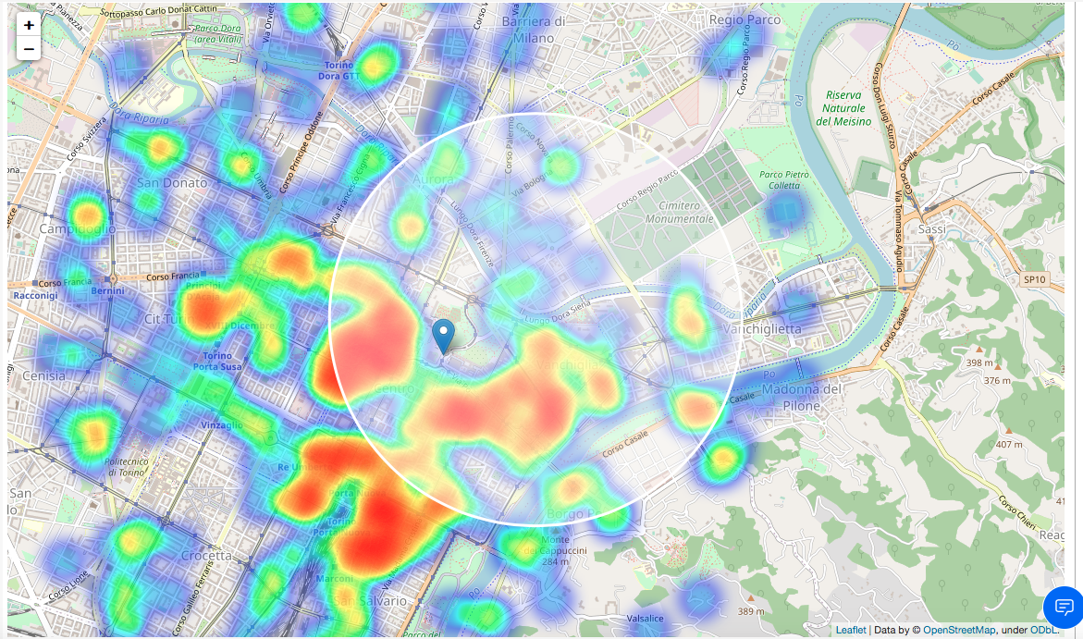

FIG. 7) The area in analysis which includes Borgo Dora and Borgo Vanchiglia.

In this new area 331 candidate neighborhoods are generated (the regularly space grids we already talked about).

Now let's calculate two most important things for each candidate neighborhood: **number of restaurants in vicinity** (we'll use radius of **100 meters**) and **distance to closest vegetarian/vegan restaurant**.

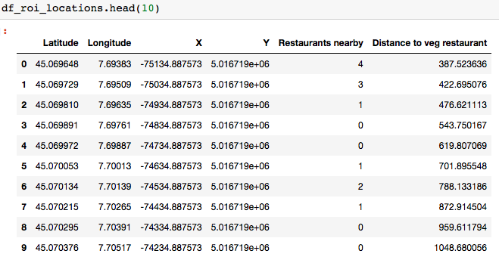

FIG. 8) The df with each grid and how many restaurants are nearby and distance to the closest veg restaurant from every center neighborhood grid.

We're interested only in **locations with no more than two restaurants in radius of 100 meters**, and, most important, **no vegetarian/vegan restaurants in radius of 400m meters**.

The results are:

Locations with no more than two restaurants nearby: **326**

Locations with no veg restaurants within 400m: **304**

Locations with both conditions met: **303**

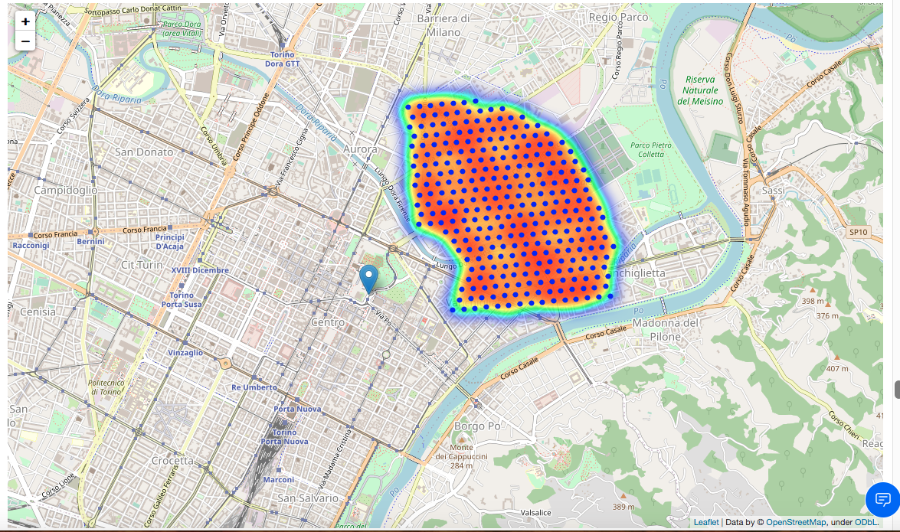

FIG. 8) The map with the **303** available location.

Let us now **cluster** those locations to create **centers of zones containing good locations**. Those **15** zones, their centers and addresses will be the final result of our analysis.

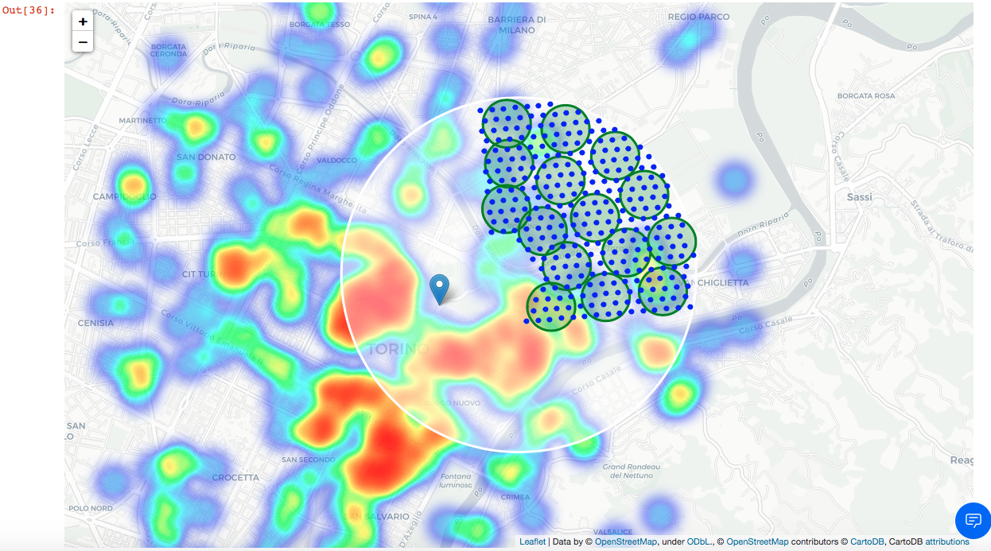

FIG. 9) The map with the **15** clusters.

The clusters represent groupings of most of the candidate locations and cluster centers are placed nicely in our boroughs.

Addresses of those cluster centers will be a good starting point for exploring the neighborhoods to find the best possible location based on neighborhood specifics.

Let's **reverse geocode those candidate area centers to get the addresses** which can be presented to stakeholders.

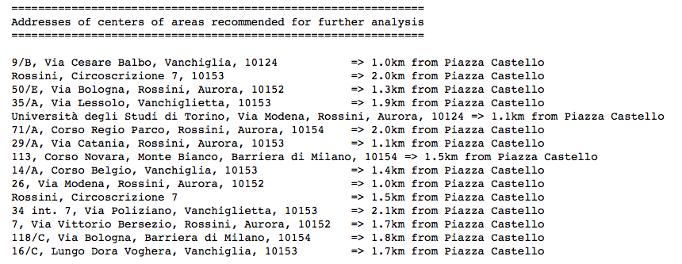

FIG. 10) Output of the reverse geocoding (with the Open Street Map API) of those 15 locations.

This concludes our analysis. We have created 15 addresses representing centers of zones containing locations with low number of restaurants and no vegetarian/vegan restaurants nearby, all zones being fairly close to city center (all less than 2.5km from Piazza Castello, and six of those less than 1.5km from Piazza Castello). Although zones are shown on map with a radius of ~100 meters (green circles), their shape is actually not so irregular, and their centers/addresses should be considered only as a starting point for exploring area neighborhoods in search for potential restaurant locations. Most of the zones are located in Borgo Vanchiglia and Borgo Dora boroughs, which we have identified as interesting due to being popular with tourists, fairly close to city center and well connected by public transport.

**Results and Discussion**

Our analysis shows that although there is a great number of restaurants in Turin (420 in our initial area of interest which was 3x3km around Piazza Castello), there are pockets of low restaurant density in Borgo Dora, in Borgo Vanchiglia and in Crocetta boroughs. Highest concentration of restaurants was detected around Piazza Castello, so we focused our attention to areas north, north-east, corresponding to boroughs Borgo Dora and Borgo Vanchiglia borough. Another borough was identified as potentially interesting (Crocetta, south-west from Piazza Castello), but our attention was focused on Borgo Dora and Borgo Vanchiglia which offer a combination of popularity among tourists, closeness to city center and a number of pockets of low restaurant density.

After directing our attention to this more narrow area of interest (covering approx. 2x2km north-east from Piazza Castello) we first created a dense grid of location candidates (spaced 100m appart); those locations were then filtered so that those with more than two restaurants in radius of 100m and those with a veg restaurant closer than 400m were removed.

Those location candidates were then clustered to create zones of interest which contain greatest number of location candidates. Addresses of centers of those zones were also generated using reverse geocoding to be used as markers/starting points for more detailed local analysis based on other factors.

Result of all this is 15 zones containing largest number of potential new restaurant locations based on number of and distance to existing venues - both restaurants in general and veg restaurants particularly. This, of course, does not imply that those zones are actually optimal locations for a new restaurant! Purpose of this analysis was to only provide info on areas close to Turin center but not crowded with existing restaurants (particularly vegetarian/vegan) - it is entirely possible that there is a very good reason for small number of restaurants in any of those areas, reasons which would make them unsuitable for a new restaurant regardless of lack of competition in the area. Recommended zones should therefore be considered only as a starting point for more detailed analysis which could eventually result in location which has not only no nearby competition, but also other factors taken into account and all other relevant conditions met.

## Conclusion

Purpose of this project was to identify Turin areas close to center with low number of restaurants (particularly veg restaurants) in order to aid stakeholders in narrowing down the search for optimal location for a new vegetarian/vegan restaurant. By calculating restaurant density distribution from Foursquare data, we have first identified general boroughs that justify further analysis (Borgo Dora and Borgo Vanchiglia), and then generated extensive collection of locations which satisfy some basic requirements regarding existing nearby restaurants. Clustering of those locations was then performed in order to create major zones of interest (containing greatest number of potential locations) and addresses of those zone centers were created to be used as starting points for final exploration by stakeholders.

Final decision on optimal restaurant location will be made by stakeholders based on specific characteristics of neighborhoods and locations in every recommended zone, taking into consideration additional factors like attractiveness of each location (proximity to park or water), levels of noise / proximity to major roads, real estate availability, prices, social and economic dynamics of every neighborhood etc.